**EXPERIMENT 8**

**Aim:** To use Numeric Transform filter and floor function to obtain the precision up to same value.

**Steps to be followed:**

**1.** Open segment-challenge.arff in the explorer in weka.

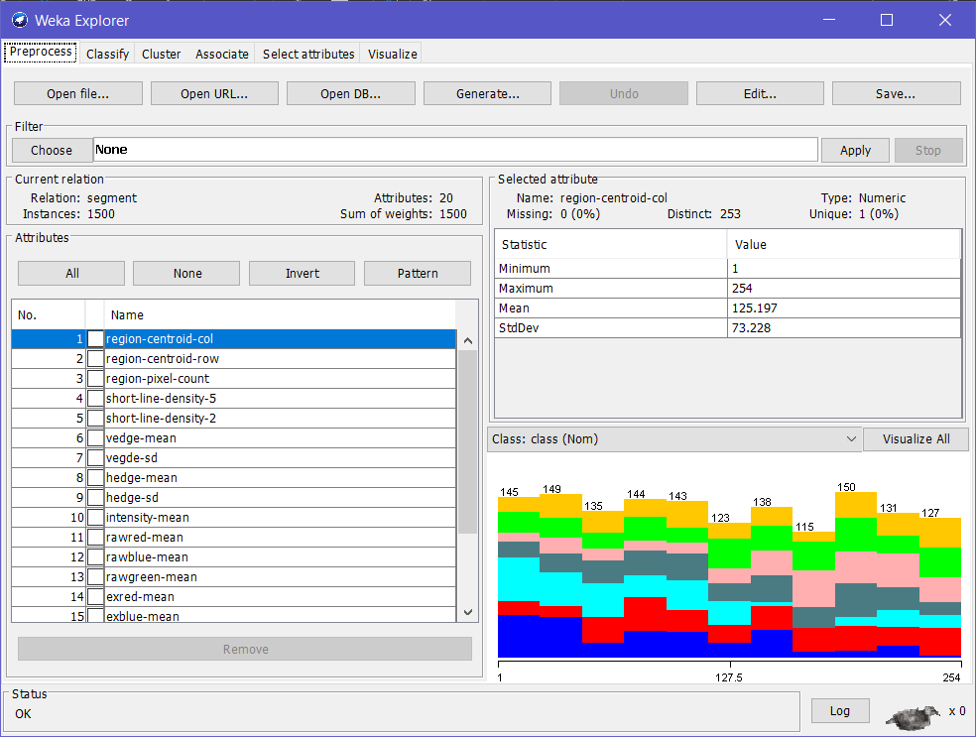

**2.** Then select the choose option after opening the file.

**3.** Preform the following.

**4.** Choose->filters->unsupervised->attribute->Numeric transform method

**5.** Click and fill the index of the column whose values are to be rounded off.

**6.** Apply these changes to all the columns by selecting all the click apply.

**7.** Click Edit to see the Viewer as shown.

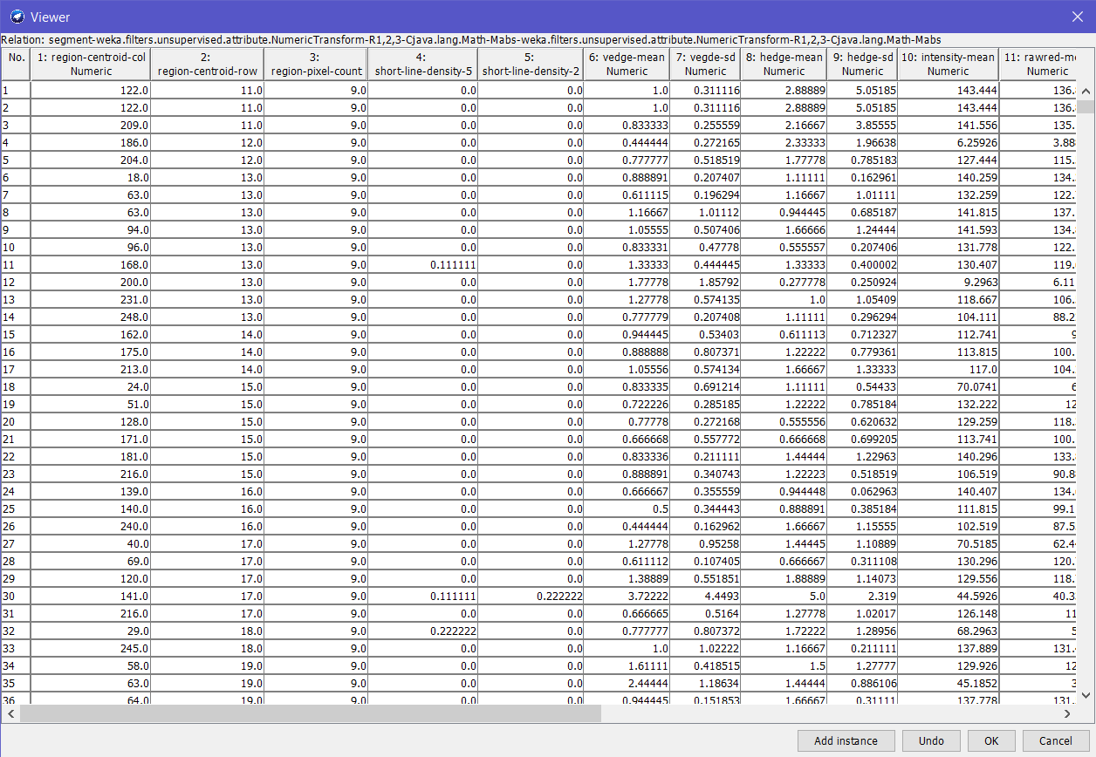

**Conclusion:**

By using Numeric transform filter and floor method, require values have been obtained.